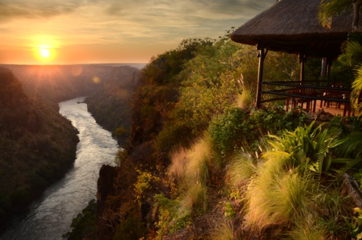

5 Day Wellness Retreat – 5 day All Inclusive Wellness retreat at Gorges Lodges Combination of Yoga and fitness, while relaxing and recuperating overlooking Batoka Gorge.

DAY 1:

- Arrive at Victoria Falls Airport to be met by a Gorges Lodge shuttle for your road transfer to Gorges Lodge (30 mins) on the edge of the Batoka Gorge, 200 metres above the mighty Zambezi River (30 mins).
- After settling in drinks overlooking the beautiful Batoka Gorge as you meet your instructors as they welcome you to the retreat.
- Freshen up and enjoy a three course dinner overlooking the magnificent Batoka Gorge.

DAY 2:

- Early morning Porter WOD Session for your first morning in Africa taking in the smells and sounds of nature.
- After a wholesome breakfast take the shuttle to Victoria Falls town for a guided tour of the Victoria Falls with some curio shopping followed by lunch at a restaurant in the town.
- Then get dropped at the riverside dock for a sundowner cruise along the mighty Zambezi River.
- Return to the lodge freshen up and enjoy dinner while absorbing the sounds of the night with a stunning view.

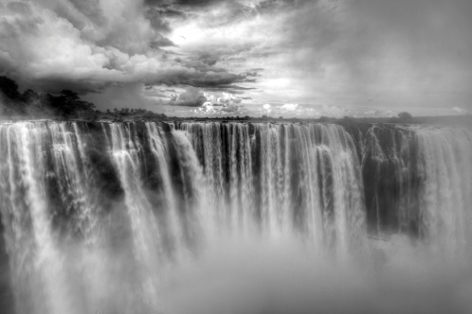

Day 3:

- Early morning Yoga session as the sun rises over the gorge.
- Visit to the School to listen to the assembly singing then return to Gorges Lodge for breakfast.
- Enjoy a private Spa Treatment on your private deck or request a treatment from one of our viewpoints overlooking the Batoka Gorge.
- After your Spa Treatment enjoy lunch at the main lodge followed by some relaxation time before your next activity.
- Zambezi Beats workout session a workout involving an African drum beat.
- Freshen up and have a three course dinner as you unwind from a busy day.
Day 4:
- Early morning Yoga session with a stunning view
- After your run freshen up and have some breakfast overlooking the Batoka gorge one last time.
- Enjoy a guided walk along the edge of the Dibu Dibu gorge experiencing the birds of prey that inhabit the area and learn about the ecosystem of the gorge as it joins the Zambezi River.
- Return to the lodge for a delicious lunch as you relax at our main lodge area.
- Request a spa treatment or choose to relax in your private room.
- Challenge yourself to a Dibu Dibu run as the day comes to an end.
- Freshen up and sit down to a tasty three course dinner overlooking the gorge, while enjoying the sounds of the night.

Day 5:

- Wake up at sunrise for your last Yoga or Fitness session; this is your choice as you enjoy your last morning on your retreat.
- Pack and freshen up before enjoying one last tasty breakfast.
- Transfer by road to Victoria Falls Internationl Airport for your departing flight.

The Wellness Retreat Experience

Porter WOD – challenge our river guiding porters to a race out of the Batoka gorge
Zambezi Beats WOD – Tabatas beat workout according to the rhythm of African drums
Dibu Dibu Run – A tough and challenging run inside the Dibu Dibu Gorge

Hatha Yoga – gentle, basic yoga classes with no flow between poses. Expect a slower paced stretching focused class with some basic Pranayama breathing exercises with relaxation and/or meditation at the beginning or end of each class. Hatha classes are good to work on your alignment, learn relaxation techniques and become comfortable with doing yoga while building strength and flexibility.
Restorative Yoga – Is the centering of your breath & body – aligning the physical and mental by practicing stillness and gentle movement for extended periods of time. It’s about slowing down and opening the body through passive stretching. If you take a restorative class, you may hardly move at all, doing a few postures in a course of an hour. During those long holds, your muscles relax deeply. It’s a completely different feeling from the other types of yoga classes since props are used to support your body as opposed to using your muscles.

Yoga Instructor – Robyn Brookes
Fitness Instructor -Andy Schultz

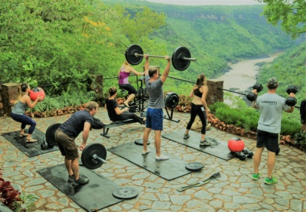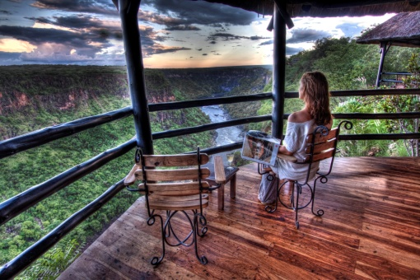

PLEASE NOTE FOR ALL PACKAGES:
- Rates include national park entry fees
- Rates for packages that include air transfers are for a minimum of 2 people and these rates are subject to change without prior notice
- Some activities are provided through 3rd party suppliers and may be subject to change
- This is a sample itinerary and may be adapted based on circumstances on the ground
- The Horse Riding Safaris and Spa Treatments are external activities from the lodge and are not inclusive of the package.
- The school visits are seasonal and according to the school calendar, if it is school holidays a village tour will be organized.

