8 Night Safari - 2 Nights All Inclusive at Gorges Lodges then 3 Nights All inclusive at Camelthorn Lodge and to end off the safari in style 2 Nights All Inclusive at Zambezi Sands River Camp with transfers between the 3 lodges included.

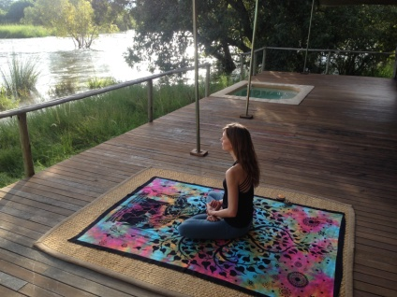

DAY 1:

- Arrive at Victoria Falls Airport to be met by a Gorges Lodge shuttle for your road transfer to Little Gorges Lodge (30 mins).
- Gorges and Little Gorges Lodge has arguably the most spectacular views in Southern Africa and offers a unique Victoria Falls experience from a peaceful and idyllic base on the edge of the Batoka Gorge.
- After settling in welcome drinks will be served as you get to meet and get to know your yoga instructors while soaking in the beautiful view.
- Freshen up and enjoy a 3 course dinner in the lodge dining room overlooking the gorge.

DAY 2:

- Early morning Yoga session for your first morning in Africa taking in the smells and sounds of nature.
- After breakfast take the shuttle to Victoria Falls town for a guided tour of Zimbabwe's foremost attraction - the Falls. “The smoke that thunders” remains one of the most spectacular natural wonders in the world. This will be followed by curio shopping at the local craft village followed by lunch at a restaurant in town.
- Then get dropped at the riverside dock for a sundowner cruise along the mighty Zambezi River.
- Transfer back to the lodge freshen up and enjoy dinner while absorbing the nights sounds of the Batoka Gorge.

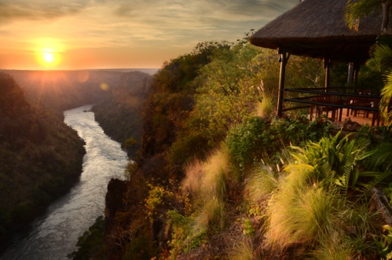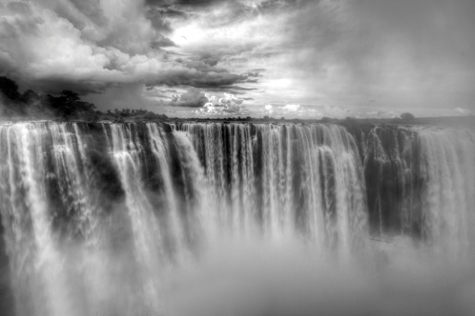

Day 3:

- Early morning Yoga session amongst as the sun rises over the gorge.
- Visit to the School to listen to the assembly singing then return to Gorges Lodge for breakfast.
- Pack up and road transfer to Dete Railway Station (approx 2 hours) where you will then board the Elephant Express rail car for a slow ride down the railway line game viewing all the way into camp (approx 2 hours). Packed snacks and refreshments will be served on board.
- A Camelthorn 4 x 4 vehicle will meet you at Ngamo Siding for your transfer to Camelthorn Lodge (10 minutes)
- Once at Camelthorn, settle into your forest villa and later enjoy a delectable 3 course dinner out under the stars. a night drive on the lodge's concession is on offer after dinner.
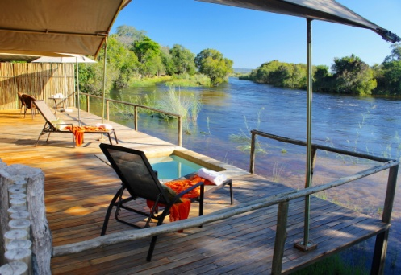
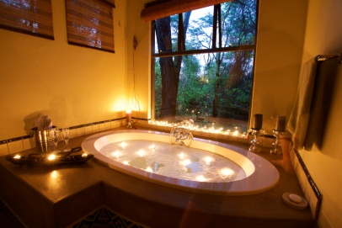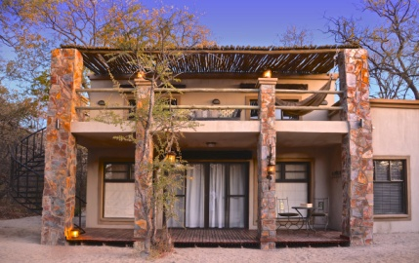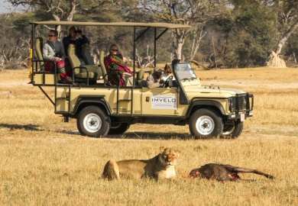
Day 4:
- Early morning Yoga class listening to the sounds of the wild animals and nature of Hwange National Park followed by a delicious breakfast.
- Take a walk in the woodlands surrounding Camelthorn, escorted by a fully licensed and experienced guide.
- Return to Camelthorn for a tasty brunch and a meditation session to relax and rejuvenate the mind.
- Afternoon game drives with sundowners and nourishing snacks at Major Pan.
- Night drive back to the lodge to freshen up before refreshments and canapés around the campfire and later a 3 course dinner in the main lodge dining room.

Day 5:
- Early morning Yoga class listening to the sounds of the wild animals and nature of Hwange National Park followed by a delicious breakfast.
- After breakfast guests have the option of choosing between a horse riding safaris or relaxing with a special spa treatment.
- A tasty brunch will then be served after which you can relax in the comfort of your villa or around the main lodge.
- An early afternoon meditation session to relax and rejuvenate the mind, followed by an afternoon game drive with refreshments taking in the views of an African sunset.

Day 6:
- Yoga session followed by a light snack and then a morning village visit and school tour at Ngamo Village where you will be able to walk or run with the school children on their way to school followed by a tour of Imvelo’s Community Projects.
- Return to Camelthorn for a late wholesome breakfast and then pack up and to Ngamo Siding for your ride on the Elephant Express along the edges of Hwange National Park to Dete.
- Road transfer from Dete to the Zambezi Sands Hub (2.5 hours), where you will be picked up by a 4x4 vehicle to take you the remaining distance to Zambezi Sands River Camp (approx 45 mins).
- Evening meditation session on the lodge deck to relax and rejuvenate the mind with the mighty Zambezi River flowing in front of you.
- Freshen up and indulge in a 3 course dinner in the elegant main lodge area.
Day 7:
- As the sun rises an early morning Yoga session listening to the rapids of the Zambezi River followed by tea or coffee and a tasty breakfast on the main lodge deck
- Tackle the mighty Zambezi River on our inflatable canoes and enjoy the sights of the river as you cruise down it.
- Stop off at one of our picturesque picnic spots for a delicious lunch and siesta before taking a slow drive back to the lodge in the afternoon
- Once back in camp relax for an hour or two in your private splash pool watching the game and birdlife on the river’s edge.
- Climb aboard our pontoon for a river cruise where you will experience a meditation drift down session while floating down the Zambezi River listening to the water flowing through the rapids.
- Return to camp and freshen up where a wonderful 3 course dinner awaits you.
Day 8:

- Wake up at sunrise and experience a yoga session and then head out one last time for a guided walk into Zambezi National Park, escorted by a fully licensed and experienced guide who will share their knowledge and love of the bush with you. Getting close up to Africa's pristine wildlife will be an experience never to be forgotten.
- Return to the camp for breakfast before packing up and catching your transfer to the Zambezi Sands Hub, where you will be transferred to Victoria Falls Airport for your departure.

The Yoga Safari Experience
‘Unite body, mind & soul ‘in the wildernesses’

On a yoga safari not only will you feel the union of your body, mind & soul; you will also feel rejuvenated & revitalized.
Surrounded by bush birds and beasts as you practice daily asana and meditation classes which will stretch your body and mind to deepen the ultimate goal of yoga, to reach a state of pure African bliss.
Ground your feet in African soil and breath in the fresh air to find your ‘inner wild’ while you do yoga on safari
Robyn Brookes – Yoga Instructor
Vinyasa Yoga - commonly referred to as flow yoga. A type of yoga that links movement and breath to attain balance in the mind and body. From the Sanskrit ‘to place in a special way’, Vinyasa aligns a deliberate sequence of poses with the breath to achieve a continuous flow. Vinyasa classes offer a variety of postures and no two classes are ever alike.
Hatha Yoga – gentle, basic yoga classes with no flow between poses. Expect a slower paced stretching focused class with some basic Pranayama breathing exercises with relaxation and/or meditation at the beginning or end of each class. Hatha classes are good to work on your alignment, learn relaxation techniques and become comfortable with doing yoga while building strength and flexibility.

Restorative Yoga – Is the centering of your breath & body – aligning the physical and mental by practicing stillness and gentle movement for extended periods of time. It’s about slowing down and opening the body through passive stretching. If you take a restorative class, you may hardly move at all, doing a few postures in a course of an hour. During those long holds, your muscles relax deeply. It’s a completely different feeling from the other types of yoga classes since props are used to support your body as opposed to using your muscles.

PLEASE NOTE FOR ALL PACKAGES:
- Rates include national park entry fees
- Rates for packages that include air transfers are for a minimum of 2 people and these rates are subject to change without prior notice
- Some activities are provided through 3rd party suppliers and may be subject to change
- Please note the Elephant Express has to run according to scheduling specified by the National Railways of Zimbabwe and as such may be subject to delays and cancellations, which are beyond our control.
- This is a sample itinerary and may be adapted based on circumstances on the ground
- The Horse Riding Safaris and Spa Treatments are external activities from the lodge and are not inclusive of the package.
- The school visits are seasonal and according to the school calendar, if it is school holidays a village tour will be organized.

